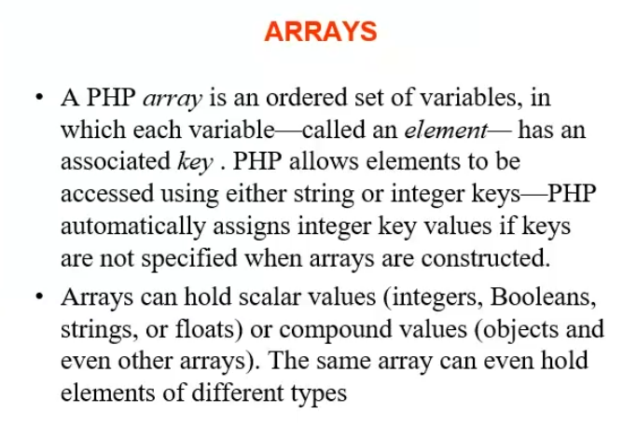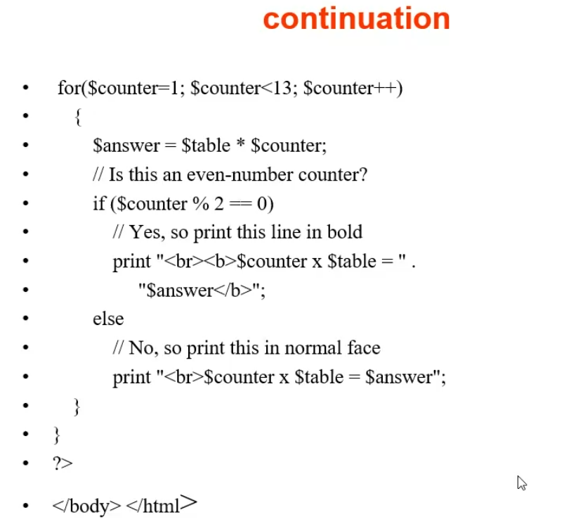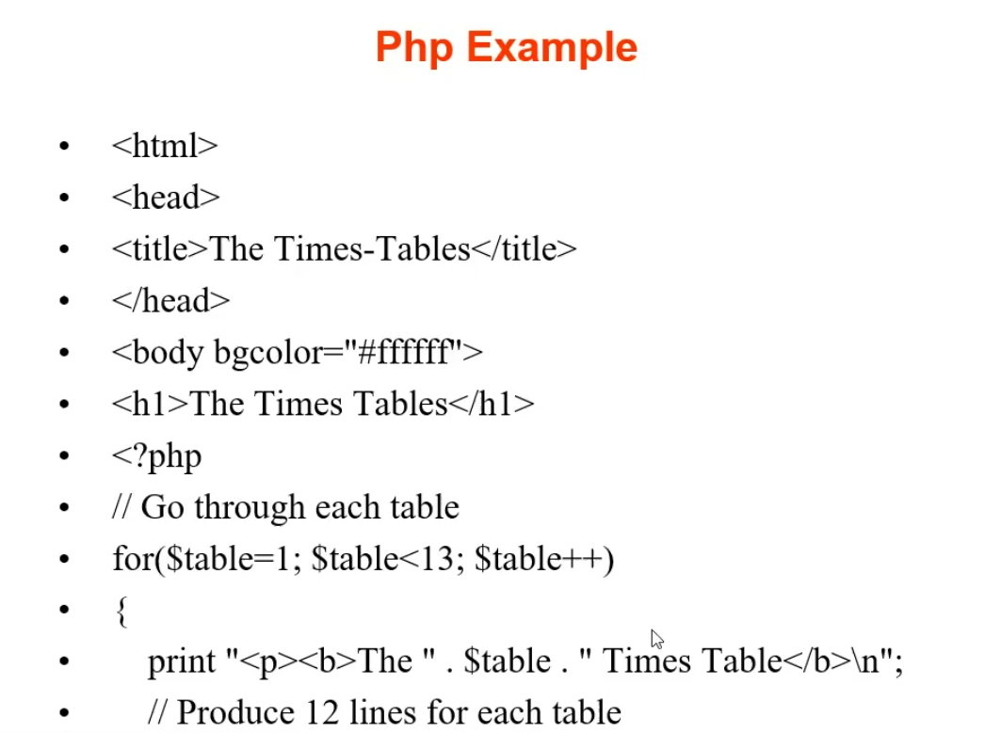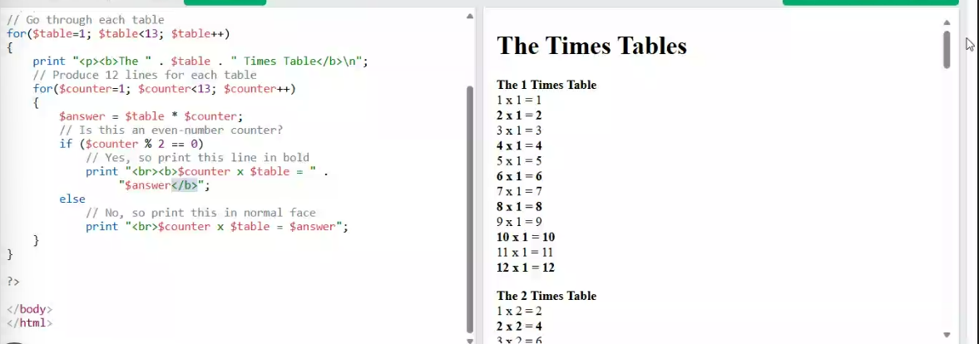<?php
// Go through each table
for($table=1; $table<13; $table++)
{
print "\n\n\nThe " . $table . " Times Table\n";
print "=========================\n";
// Produce 12 lines for each table
for($counter=1; $counter<13; $counter++)
{
$answer = $table * $counter;
// Is this an even-number counter?
if ($counter % 2 == 0)
// Yes, so print this line in bold
print "\n$counter x $table = " .
"$answer"."\t(Even Number)";
else
// No, so print this in normal face
print "\n$counter x $table = $answer"."\t(Odd Number)";
}
}
?>

<!DOCTYPE html>
<html>
<body bgcolor="#84FF83">
<h1>The Times Tables</h1>

<?php
// Go through each table
for($table=1; $table<13; $table++)
{
print "<p><b>The " . $table . " Times Table</b>\n";
// Produce 12 lines for each table
for($counter=1; $counter<13; $counter++)
{
$answer = $table * $counter;
// Is this an even-number counter?
if ($counter % 2 == 0)
// Yes, so print this line in bold
print "<br><b>$counter x $table = " .
"$answer</b>";
else
// No, so print this in normal face
print "<br>$counter x $table = $answer";
}
}

?>

</body>
</html>
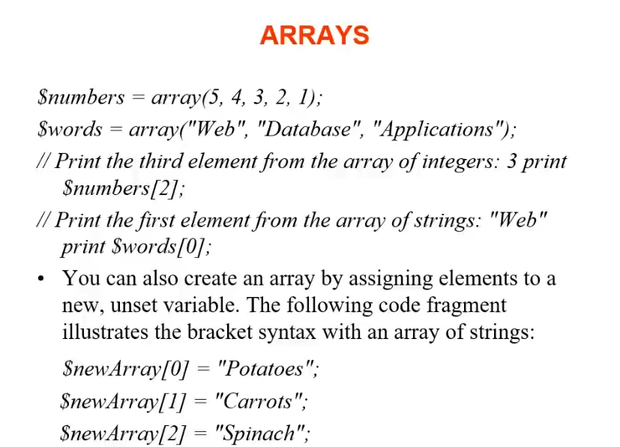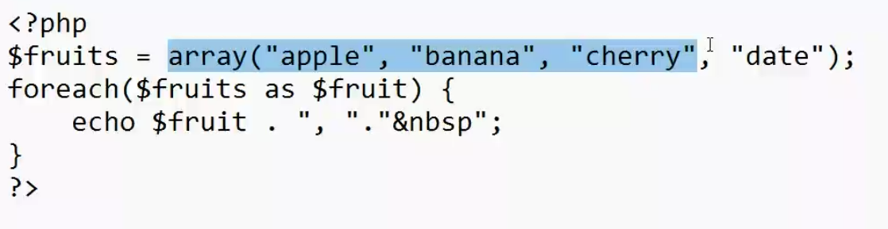
<?php
$fruits = array("apple","banana","cherry");
foreach($fruits as $fruit){
echo $fruit ."\t";
}
?>